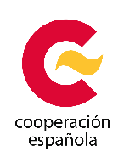
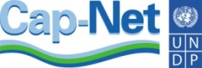

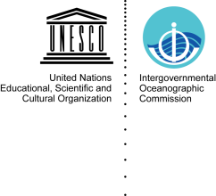
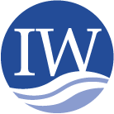
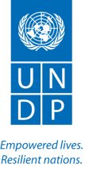
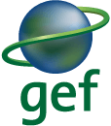

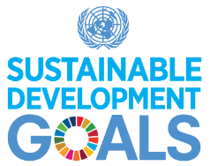
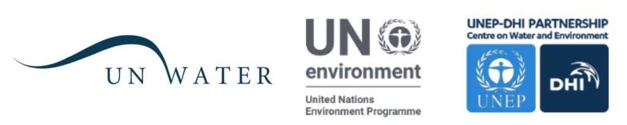

4th Targeted Regional Workshop for GEF International Waters Projects in Latin America & the Caribbean and Cap-Net UNDP Annual Meeting
AECID Montevideo Training Centre, Uruguay
October 9-13 2017

- Introduction
There is a continuing threat to global water resources as well as to the ecosystems they support, which has significant negative consequences on the human population's ability to feed themselves, maintain health, seek economic development and avoid expensive investments to mitigate damage. The international water system is an important source of income and food for a large part of the world's population whose food and water sources are now in danger.

A joint workshop, conducted by GEF IW: LEARN, UNDP Cap-Net and partners, will be held for knowledge transfer on international waters, effectiveness of information systems and the exchange of experiences for its integration into the GEF and Cap-Net UNDP project portfolio and its partners worldwide. GEF IW: LEARN workshops focus on transferring management approaches, tools and best practices amongst GEF projects and partners. Together with project-project twinning exchanges and the GEF Biennial International Waters Conference, these face-to-face training activities are part of a cycle of learning and partnership building across the portfolio and its partners.

The barriers to addressing and improving the management of international water projects are:
- Lack of adequate scientific knowledge, knowledge of best practices and limiting the adoption of effective management for decision-making and actions;
- Inadequate institutional arrangements, stakeholder involvement and sustainable financing
- Outdated strategic planning and public policies

The GEF IW:LEARN project (www.iwlearn.net), whose latest phase became active in 2016 and runs through 2020 has as one of its primary activities, the organization of regional workshops for GEF IW projects in three GEF regions: Latin America & the Caribbean, Asia & the Pacific and Africa. The workshops are also about transferring management approaches, tools and best practices amongst GEF projects and partners. Together with project-project twinning exchanges and the GEF Biennial International Waters Conference, these face-to-face training activities are part of a cycle of learning and partnership building across the portfolio and its partners.

The workshop will also host Cap-Net´s UNDP annual network mangers´ and partners meeting.

Cap-Net is an international network for capacity development for sustainable water management. It is made up of an association of international, regional and national institutions and of networks committed to the development of capacities in the water sector. Cap-Net is part of the United Nations Development Program (UNDP). Each year, since 2002, there is an annual meeting of affiliate network managers and international partners.

The annual meeting has the main objective of elaborating work plans that will be developed during 2018. Specific topics are related to measuring capacity development impact; innovative activities such as online education; opportunities for collaboration and development of activities; and sharing experiences and lessons learned.

The meeting will also provide the opportunity to share progress on the “Integrated Monitoring of Water and Sanitation Related SDG 6 Targets”, referred to as the Global Expanded Monitoring Initiative, or GEMI which was launched in 2015 under the UN-Water umbrella. GEMI’s specific long term goal is to (i) establish and manage, by 2030, a coherent and unified monitoring framework for water and sanitation to inform the post-2015 period and (ii) contribute to country progress through well-informed decision-making on water, based on harmonized, comprehensive, timely and accurate information. The scope of GEMI is primarily limited to SDG 6, but it will also contribute indirectly to monitoring proposed related indicators in other SDGs.

- Objectives
The training course/workshop aims to provide participants with the knowledge and skills necessary to support a process of sustainable and effective governance of water, at the level of international waters and in the context of the Sustainable Development Goals.

It is expected to incorporate a systematic ecosystem approach in line with IWRM and coastal zone management and trans boundary cooperation. Cross-cutting themes and practical mechanisms will be worked on to be incorporated into development projects in participating countries. Appropriate approaches and methodologies tested in the framework of Global Environment Facility (GEF) and GEMI projects will be shared.

It is expected that lessons learned will be incorporated into current practices and strategic plans of participating organizations for the review of policies, regulations, participation mechanisms and access to information. Likewise, it is expected that knowledge will be shared and replicated, through its integration in projects and in the form of new courses reaching a larger and diverse number of people. In addition, this course will facilitate the strategic planning of the collaboration between Cap-Net UNDP, GEF, and UN Water.

Specific objectives
- Sharing knowledge on the basic concepts of international water management, IWRM and its links with Sustainable Development Goals
- To deepen aspects of water governance levels: planning, institutions, policies, participation and financing
- Share experiences, cases, guidelines and available learning resources
- Strengthen collaboration between Cap-Net affiliated networks, GEF International Waters Projects, and GEMI Project
- Progress in work plans for 2018 and strategic planning of Cap-Net UNDP for the period 2018-2020.

Contents and methodology
- International waters
- IWRM and Sustainable Development Goals
- Gender mainstreaming
- Climate change
- Conjunctive management
- Private sector engagement
- Sustainable Development Goals, Integrated Monitoring of Water and Sanitation Related SDG 6 Targets (GEMI Project)

The structure includes content presentations; revision of tools guidelines and case studies; group work; and open sessions. The meeting will consider specific sessions for work planning and partnership strengthening.

Participants are expected to share experiences and for this the program considers diverse spaces of interaction and group work. Each participant will receive a set of training materials related to the course.

Course contents and materials are based on training manuals and other learning resources developed by Cap-Net UNDP; GEF IW: LEARN Program; and UN Water - UN Environment (GEMI Project).

- Participants
The activity is open to participants from Latin America and also globally. Cap-Net UNDP affiliated network managers and international partners are especially invited to apply.

All sessions and materials will be in English language.

Other stakeholders can represent various stakeholders associated with water governance and water capacity development, representing public agencies, civil society organizations, knowledge centres, and the private sector.

The activity is open to a maximum of 40 participants. Gender and geographic balance will be considered.

